EasyBusiness

This document explains how the company which will use this software works and how the software is going to change it, making the work simpler, more effective and try to reduce costs for the business. This specific company is called Ypsilon Fresh Juices and is a very small juice factory with less than ten employees.

**The owner/manager:**

The owner of the company is also the manager which has many responsibilities. The manager is responsible to check and record the stock daily. For instance, if a product is about to run out he has to schedule the next production date. Additionally, he has to make the appropriate orders in supplies so that the factory has everything for the production such as ingredients or bottles. The most important responsibility he has is to manage the company finances, checking all the profits so that he can reduce the costs. He must be able to pay all the suppliers at the right moment so that the company can have the stock required to begin production. Furthermore, the manager must record all financial transactions. For example, checking the employee's working hours so he can process their payments and making sure that customers have paid the supplied products by checking the invoices brought back from the salesmen.

Lastly, during the production time, the manager has to review if everything is going as planned. If something goes wrong, he has to be able to fix it. At the end of each production, the employees are recording the quantity of the items produced and reporting it to the manager for review.

**The salesmen:**

The salesman has to go to the factory to stock the van and log what he takes from the storage rooms daily. He has to give the records to the manager and then start working by going to each client to sell the products. At the customer's store, he has to check what products are sold out and refill what is missing. After that, he has to record every sale in an invoice which will be checked by the customer to agree with the products being sold, sign and pay the salesman. The salesman will do this for each customer in his schedule for the day. If he finishes from all the customers he goes back to the factory to return in the products that are left (not sold) to storage and record how many products were sold and how many are left. Finally, the salesman writes down his working hours and gives it to the manager for approval along with the sales and stock record for the day.

**Other employees:**

During the production some other workers are also employed by the client for production but are not relevant to the new application. Their main responsibility is to report their working hours to the manager.

**Owner – Desktop & Android Application:**

The manager has the responsibility to check the stock daily using the desktop application. Once a week he can go to the storage to count everything manually and check if it matches the android application's reports. The applications will be updated once a day so the manager will not have to go to check everything each day. In the case of a product running out, then both applications will notify the manager so he can check it and schedule a production date or order supplies. As mentioned above the manager has the responsibility to manage the company finances.

By using the desktop application will help the manager to check everything and record everything there. For example, he will not have to check all invoices one by one to check if a client paid him, but the desktop application will make the calculation automatically and show him whether or not any problems appear. There will be graphs showing the profits and the losses of the company per period. Additionally, he will not have to make the calculations for each employee because if he uses his Android application to record their working hours he will have the payments ready for each month.

When the manager wants to check the supply costs he will have to record everything the day that the supplies are coming into the company. He will record the supply, quantity and the price. In this way, the Desktop application will show him anything that he needs to know in terms of stock. For example, if they are using too many bottles than they need or if there are any other problems during the production this would be reported to the manager by the desktop application.

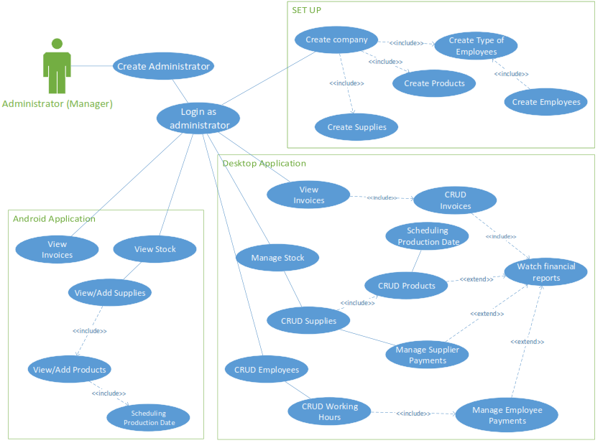

**The salesmen - Android application:**

The salesman has to go to the factory to stock the van and log what he takes from the storage rooms daily. He will log the data into the Android application and save it so he will not have to go to the manager for review. In this way, the manager will see the updates in the Android application or the desktop application as well. Then he will go to each client to sell the products. With the help of the application, he will have an organized list showing him the daily customers. At the customer's store, he has to check what products are sold out and refill what is missing. After that, he has to record every sale in an invoice which will be stored in the application by simply refilling all the important details. The application will make all the proper calculations automatically and the salesman will simply have to print the invoice. Then the customer will check the invoice and if he agrees with the products being sold they will both sign and the client will pay the salesman. This procedure will happen for each customer in the salesman's schedule for the day. When he finishes from all the customers he will go back to the factory to return the products that are not sold into storage. The only thing that he has to do is to check if the total stock left matches the application's total amount.

Additionally, the salesman will be able to see his working hours without wasting time recording it and giving it to the manager. The manager can view the sales by using either the android application or the desktop application. Finally, the manager can view the stock and the working hours of all salesmen for each day.

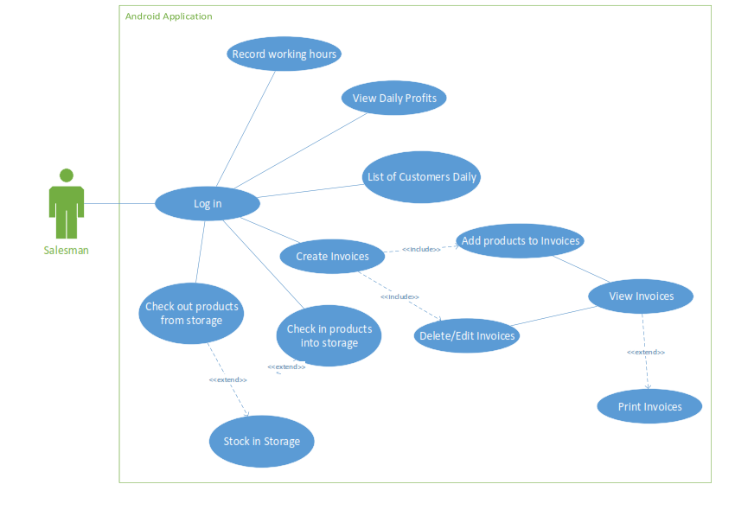

**MOSCOW Rules Agile:**

**Administrator:**

|  |  |  |
| --- | --- | --- |
| **Form** | **Name** | **Moscow** |
| Set Up | Create Admin | Must |
|  | Login Form | Must |
|  | Create Company | Must |
|  | Create Products | Must |
|  | Create Employees   * Type of Employees | Must  Should |

|  |  |  |
| --- | --- | --- |
| **Form** | **Name** | **Moscow** |
| Desktop Application | Login | Must |
|  | Manage Stock   * CRUD Supplies * CRUD Products | Must  Must  Must |
|  | Scheduling Production | Should |
|  | View Invoices   * CRUD Invoices | Must  Should |
|  | CRUD Employees   * CRUD Working Hours * Manage Employee Payments | Should  Could  Would |
|  | Manage Supplier Payments | Could |
|  | Watch Financial Reports | Should |

|  |  |  |
| --- | --- | --- |
| **Form** | **Name** | **Moscow** |
| Android Application | Login | Must |
|  | View Stock   * View Supplies * Add Supplies * View Products * Add Products | Must  Must  Should  Must  Should |
|  | Scheduling Production | Should |
|  | View Invoices | Should |

**The Salesmen:**

|  |  |  |
| --- | --- | --- |
| **Form** | **Name** | **Moscow** |
| Android Application | Login | Must |
|  | Create Invoices   * CRUD Invoices * View/Print Invoices | Must  Must  Must |
|  | Check in products into the storage | Must |
|  | Check out products from the storage | Must |
|  | List of Customers Daily | Should |
|  | View Daily Profits | Could |
|  | Record/View Working Hours | Could |